**Project Design Phase-II**

**Data Flow Diagram & User Stories**

|  |  |
| --- | --- |
| Date | 06 November 2023 |
| Team ID | NM2023TMID08291 |
| Project Name | Project – Estimation of business project |

**Data Flow Diagrams:**

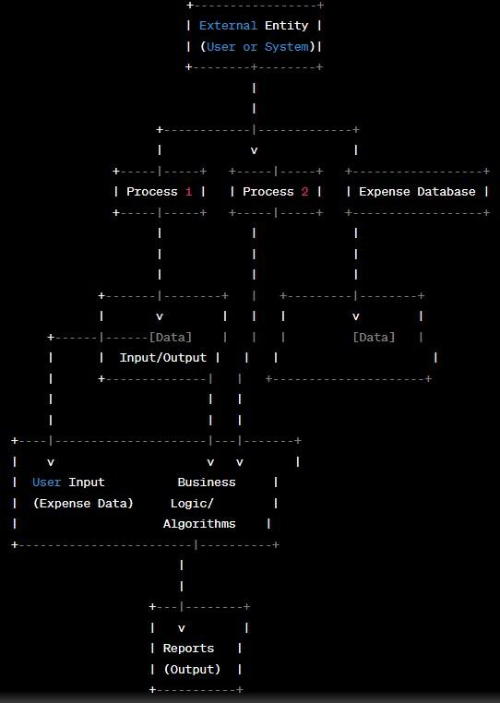

**User Stories**

|  |  |  |  |  |  |  |  |
| --- | --- | --- | --- | --- | --- | --- | --- |
| **User Type** | **Functional**  **Requirement (Epic)** | **User Story**  **Number** | **User Story / Task** | **Acceptance criteria** |  | **Priority** | **Team Member** |
| Customer  (Mobile user) | Registration | USN-1 | As a user, I can register for the application by entering my email, password, and confirming my password. | I can access my account / dashboard |  | High | Karthick.M |
|  | Possibilities checking | USN-2 | As a user, I will receive confirmation email once I have registered for the application  throught the customer reviews | I can receive confirmation email & click confirm |  | High | Sathish.S |
|  | Data cleansing | USN-3 | As a user, I can pickup the collections from any dataservers | I can register & access the dashboard or kaggle |  | Low | Sarathy.P |
|  | Accessbility | USN-4 | As a user, I can register for the application through Gmail |  |  | Medium | Abdul kathar.j |
|  | Login | USN-5 | As a user, I can log into the application by entering email & password |  |  | High | Anbarasan.K |
|  | Dashboard |  |  |  |  |  |  |
| Customer (Web user) |  |  |  |  |  |  |  |
| Customer Care Executive |  |  |  |  |  |  |  |
| Administrator |  |  |  |  |  |  |  |
|  |  |  |  |  |  |  |  |
|  |  |  |  |  |  |  |  |
|  |  |  |  |  |  |  |  |